|  |
| --- |
| Lander University CIS 499 |
| Home Hustler |
| Scope Statement |
| Blake Edens, Waylon Ergle, Mattia Galanti |

|  |
| --- |
| 1-23-2019 |

**Project:** Home Hustler – Housing Search Engine

**Client:** Paul Cuenin, Marketing Director at Greenwood Partnership Alliance

**Faculty Supervisors:** Dr. Fahra Ali

**Justification:** Popular real estate search engines such as Zillow lack search optimization based on commuting costs. Commuting costs can add significant drawback to personal finances when gas consumption, depreciation, maintenance and time loss are considered. On average, each mile of commuting will cost $170 per year. When factoring in time lost through commuting, the potential loss of on-the-clock pay increases commuting cost substantially. Factoring in time loss for an employee who earns $25 per hour, each mile of commuting will cost $795 per year. Home Hustler offers a search engine capable of optimizing commute costs for to-be homebuyers, allowing them to find the perfect balance for their budget.

**Problem Characteristics and Requirements:**

**Functional:**

1. Search
2. Sort Results
   1. By estimated total yearly/monthly cost
   2. By estimated yearly commute cost
   3. By commute distance
   4. By listed price
3. Account Management
   1. Creation
   2. Modification
   3. Login
   4. Logout

**Non-Functional:**

1. Intuitive and easy to use
2. Highly responsive
3. Platform independent
4. Scalable – hosting service can be configured to dynamically handle traffic
5. Growth potential – future implementations can expand functionality to include mortgage estimates, brokerage services, etc.

**Project Feasibility:** Designing the website will require the use of HTML, CSS, SQL, PHP and Javascript, as well as jQuery and AJAX for Google Maps API calls. Group members have proven experience in use of the aforementioned. Use of a housing data API is also required to obtain available listings, square footage, room count, etc. The use of Bootstrap and/or Colorlib templates will speed up the design process considerably and allow more time to be spent on development functionality. All group members are confident that documentation and implementation processes will be complete by stated deadlines, barring any unforeseen circumstances.

**Beneficiaries:** Potentially anyone in need of a house could be a beneficiary.

**Project Deliverables:**

1. Scope statement
2. Analysis and design diagrams and documents
   1. Gantt chart
   2. Use cases and use case descriptions
   3. Class diagrams
   4. ER diagram
   5. Activity diagram
   6. Sequence and communication diagrams
   7. Windows navigation diagram
3. Source Files
4. Admin training

**Project Milestones:**

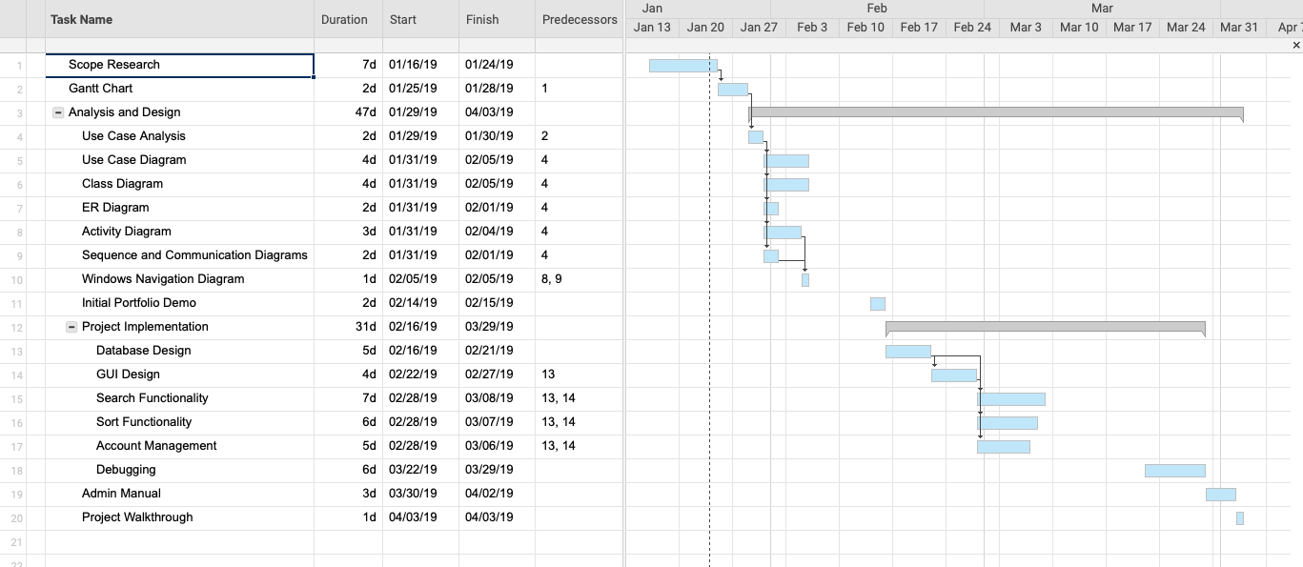

**Success Criteria:** The program should include all of the features requested by the client, operate with little to no issues, and be delivered on time. The program should carry out all functional and non- functional requirements. The program should contribute to the search of houses by providing the relative information desired by the searcher.

**Team Limitations:**

1. Work
2. Academic sport activities
3. Other classes
4. Unexpected life events

**Disclaimer:** This scope statement may change at any time at the discretion of our supervisors.